**MESD LMS Documentation – Work/Download Assignment**

**Purpose**

Allow learners to work on and/or download their assignments in their various classes.

**Usage**

1. Log in as a **Learner.**
2. Navigate to a course/class.
3. Click on an assignment.

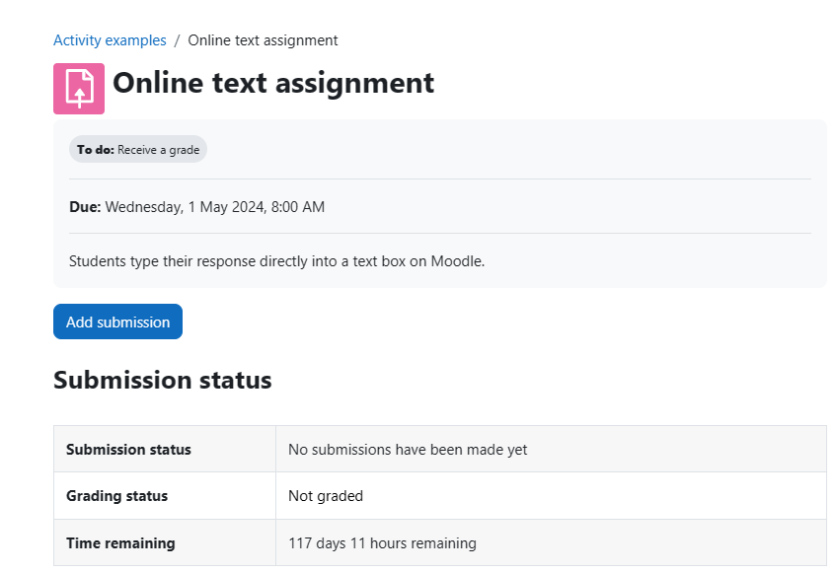

1. Click **Add submission** to submit your assignment.
2. Learners can download an assignment that’s a file by simply clicking on the file.
3. The same can be said for quizzes. Learners should click on the quiz then click **Attempt quiz**.

